**GO TO MARKET STRATEGY**

Go-to-market or go-to-market strategy is the plan of an organization, utilizing their inside and outside resources (e.g. sales force and distributors), to deliver their unique [value proposition](https://en.wikipedia.org/wiki/Value_proposition) to customers and achieve [competitive advantage](https://en.wikipedia.org/wiki/Competitive_advantage)

The end goal of a go-to-market strategy is to enhance the overall customer experience taking into account various aspects of the value proposition such as the quality of the product and pricing.

**PRICING OF APP:**

**How much should an app cost?**

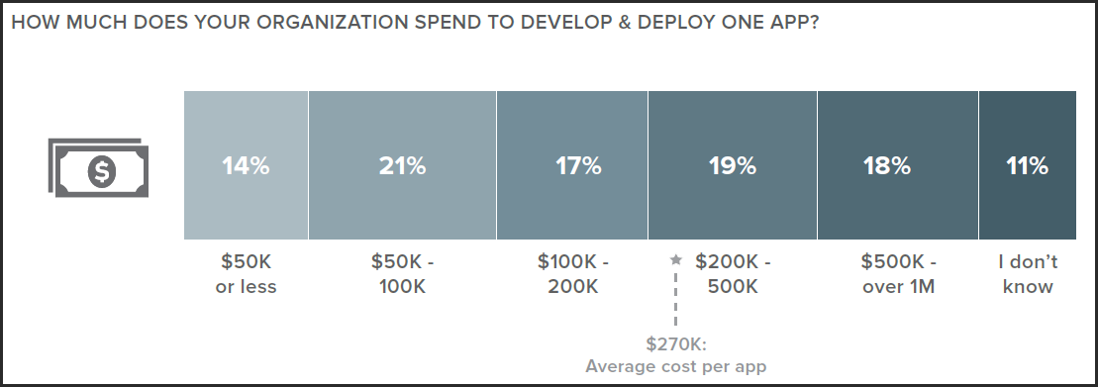

<http://howmuchtomakeanapp.com/estimates/results> **- We can use this link to search how much will our app cost.**

* The costs of apps are largely based on features, complexity, and platform.
* Apps with back-end servers will almost always cost more.
* Simple apps for one platform will start around $25,000.
* More complex apps cost six figures but can push up over $1,000,000.
* Don't forget to budget for updates, marketing, your own salary, and other costs.

**Apps built by smaller shops, possibly with only 2-3 people, likely cost anywhere between $50,000 to $100,000.**

**How to Market Your Mobile App ?**

1. **QR Codes**: When you’re targeting the smartphone generation with a mobile app, QR codes are the best way to advertise. You can add them to your website.
2. **Mobile Advertising:** Google offers [mobile ads](http://www.google.com/ads/mobile/) to target users while they are searching on their mobile devices…
3. **Social Advertising**: It allows you to **target people specifically by demographics and interests**. So, if you know the most likely users of your mobile app, you can make sure they are the only ones who can see and click on your ads. With Facebook ads, you can get pretty specific.

**Mobile App Marketing Agencies :**

* [Appspire.me](http://appspire.me/) – specializes in getting your app the most quality users possible. Many of its clients went from a few downloads per day to hundreds.
* [Appency](http://www.appency.com/) – is the global leader in mobile application marketing. It provides a full range of marketing services, from branding and consultation services to managing your launch and long term success with PR, social marketing, paid media management, and more.
* [Appular](http://appular.com/) – has unrivaled Marketing, PR, Media Buying, Consulting and Social Media services and solutions that are constructed exclusively to give your projects the absolute best chance for long term success.

**PROFIT FROM AN APP :**

**1. Enter a Contest or Event**

**2. Use Mobile Networks for In-App Advertising**

**3. Employ Rich Media Networks**

**4. Mobile Advertisements**

**5. Promotion**

**7. Subscription Fees**

**8. Sponsorships**

**DEMAND ORIENTED METHOD:**

**DEFINITION:**

[Method](http://www.businessdictionary.com/definition/method.html) in which price of a [product](http://www.businessdictionary.com/definition/product.html) is changed according to its [demand](http://www.businessdictionary.com/definition/demand.html) higher price when the demand is strong, lower price when it is weak.

**COMPETETIOR ORIENTED METHOD:**

A pricing [method](http://www.businessdictionary.com/definition/method.html) in which a [seller](http://www.businessdictionary.com/definition/seller.html) uses prices of [competing](http://www.businessdictionary.com/definition/competing.html) products as a [benchmark](http://www.businessdictionary.com/definition/benchmark.html) instead of considering own [costs](http://www.businessdictionary.com/definition/costs.html) or the [customer](http://www.businessdictionary.com/definition/customer.html) [demand](http://www.businessdictionary.com/definition/demand.html).

It focus solely on what the competition is charging, and strive to meet or beat those prices. Sometimes this strategy is referred to as a rock-bottom pricing strategy, or a low price leader strategy. The goal is to best your biggest competitors based on pricing alone. As Web Marketing Today exhibits, the competition-based pricing strategy is used by many large retailers on the Internet. Because the same products are available from multiple sources, the consumer buying decision is simply to select the retailer with the lowest price. This pricing strategy is a difficult one for small businesses to maintain, because it provides very narrow profit margins that make it challenging for the business to achieve enough momentum to grow.

**COST PER INSTALLATION:**

 iOS app CPI in US – $1.64

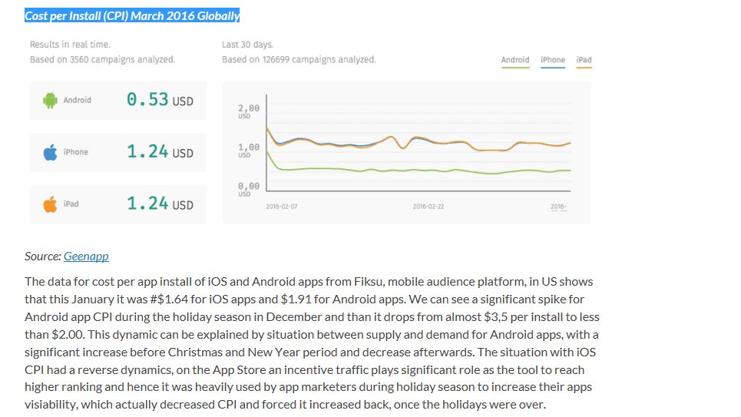

<http://www.mobyaffiliates.com/blog/average-cost-per-install-apps/>

**Use this as reference**